# Overview

The Rock branching strategy is based on the [Git Branching Model](http://nvie.com/posts/a-successful-git-branching-model/) documented by Vincent Driessen.

# Branches

## Master

The master branch should always reflect the latest production-ready state, and should be tagged with the appropriate release number. The only time the master branch is updated is when a release or hotfix branch is merged into master, at which point it is tagged with the appropriate version number. Development should never occur from the master branch.

## Develop

The develop branch is always the latest runnable code. A developer should always be able to pull the latest version of the develop branch, run an update-database to create a test database, and then be able to code and test against this.

When a developer needs to make an update to the source code, they need to decide whether to create a feature branch (documented below), or work directly off their local version of the develop branch. If there’s any chance that while working on a specific code change, they may need to make a separate unrelated change, then they should create a local feature branch rather than working directly from the develop branch. If making a small change that will be committed/pushed quickly, then developers can work directly off of their local develop branch.

A good rule of thumb, is that if a change requires more than a day’s time to develop and test, then it should probably be done in a feature branch. If it can be completed within a day, then it can be done on the develop branch

## Feature

A feature branch is used to develop new features for a future release. Feature branches should be branched from develop and eventually merged back into develop. The naming convention for feature branches is feature-[Initials]-[name-of-feature]. For example feature-drt-add-campus. Typically, feature branches would only exist in the developers repository, however, if more than one developer are working on (or reviewing) a specific feature, that feature branch can be pushed to the remote origin repository (GitHub). Once a feature has been completed, the feature branch is deleted from both the developer’s repository and from the remote repository.

## Release

A release branch is created when development has been completed for a particular target release. The naming convention for release branches is release-[version-number]. For example, release-1.0. Release branches are branched from the develop branch and will be created in both the remote repository, and in the local repository of any developer working on the release.

Once the release is ready to be distributed, the release branch is merged into the master branch, and the master branch is tagged with the release number. If any changes were made to the release branch after it was branched from develop, it will then also need to be merged back to develop. The release branch is then deleted from both local and the remote repository.

## Hotfix

A hotfix branch is created when an issue is discovered for the latest release. Hotfix branches are similar to release branches in naming convention and how they are treated when complete. The difference is that they are branched from the master branch rather than the develop branch. Naming convention is hotfix-[version-number]. For example hotfix-1.0.1.

Just like a release branch, once development and testing are complete for the hotfix, it is merged into the develop and the master branch, which is then tagged with the updated version number. The hotfix branch is then deleted from both the remote and local repositories.

## Support

A support branch is created when a critical bug is found on a previous version of the application and a customer using that version cannot upgrade to the most recent version. A support branch will be branched from the master branch at that version’s tag on the master branch. For example, if the latest released version number is 1.0 and a bug is found in version 1.0, a hotfix branch rather than a support branch would be created. That hotfix branch is then merged back into master, and master would be tagged 1.0.1. If an issue is found with the 1.0.1 version after version 2.0 has already been released (and merged into master), then a support branch would be created by branching from the 1.0.1 tag position in the master branch. That support branch is never merged back into any other branch. It remains as long as that version of the application needs to be supported. Once the change has been made to the support branch and tested and released, it should be tagged with an appropriate version number (i.e. 1.0.2). If further support needs to be done on a previous release, a hotfix branch could be branched from the support branch and then merged back into the support branch, similar to how hotfix branches are used on the most recent version on the master branch.

## Custom

Custom branches are special branches used by the organizations that are contributing to the development of the application and includes code/data that is specific to their organization. The naming convention for a custom branch is custom-[organization domain]. For example custom-ccvonline. It is up to each of those organizations to determine how their branch is managed and how and when code from the develop and/or master branches is merged into their specific custom branch.

# Using SmartGit

## New Branch

It is easiest if you switch to the branch that you would like to branch from. For example if creating a new release branch, switch to the develop branch.

Select *Branch -> Check Out* from the menu. Make sure that the correct branch/commit is selected in the list of commits. You can filter the list of branch/commits based on selected branches using the “Branches” button in the top right part of the screen. Once you’ve selected the correct commit, click the “Check Out” button.

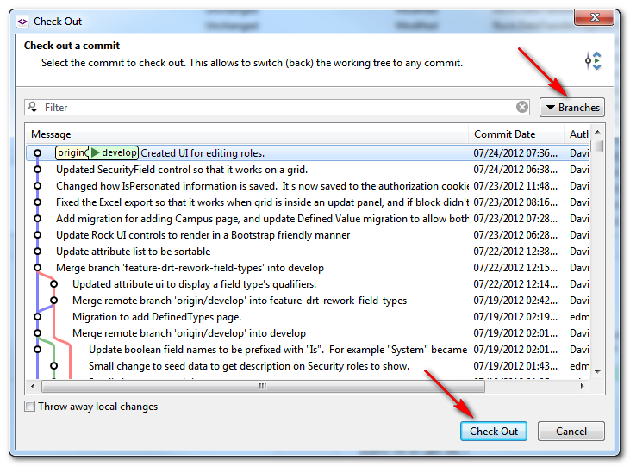

Then enter the name for your new branch, and UNSELECT the “Track remote branch” option. In all of the SmartGit dialog windows, this is the only place where we don’t use the default option.

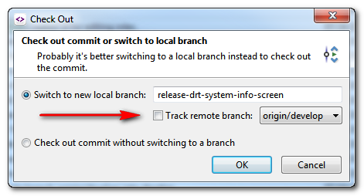

This creates a new branch in the local repository. You can view all the local and remote branches by using the *Branch -> Branch Manager* menu option…

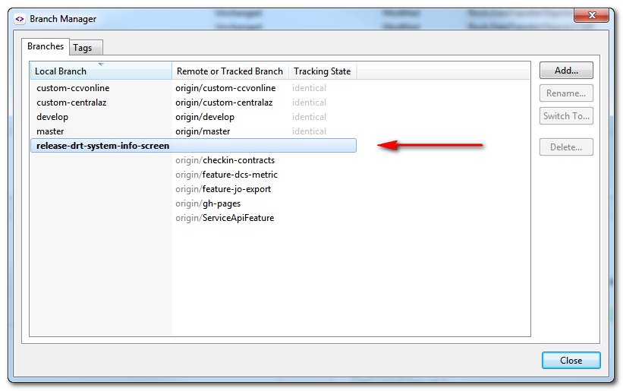

## Committing Changes

Once you’ve created a new branch, it is important to commit changes often. You do have the option of combining a commit with the previous commit by selecting the “Amend last commit instead of creating new one” option…

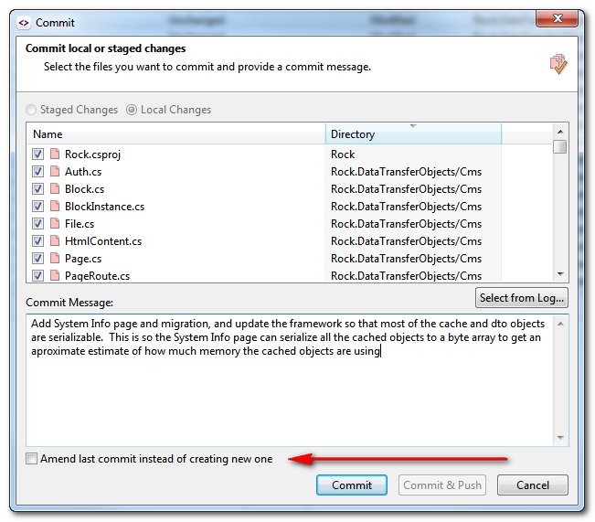

## Pushing Branch

To push a branch to the remote repository (GitHub) for other developers to see or work on, you simply do a push when viewing the branch. Select the “Push” button…

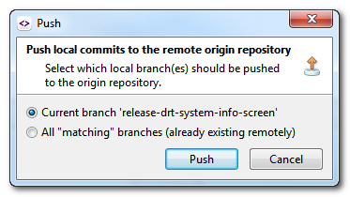

The first time you push to the remote repository, SmartGit will ask if you’d like to configure tracking for the remote branch. You should select the “Configure” option…

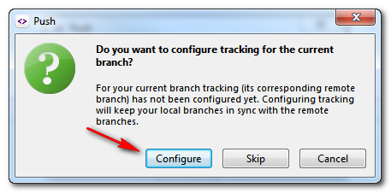

Now the branch will also be on the remote repository for other developers to pull to their local repository…

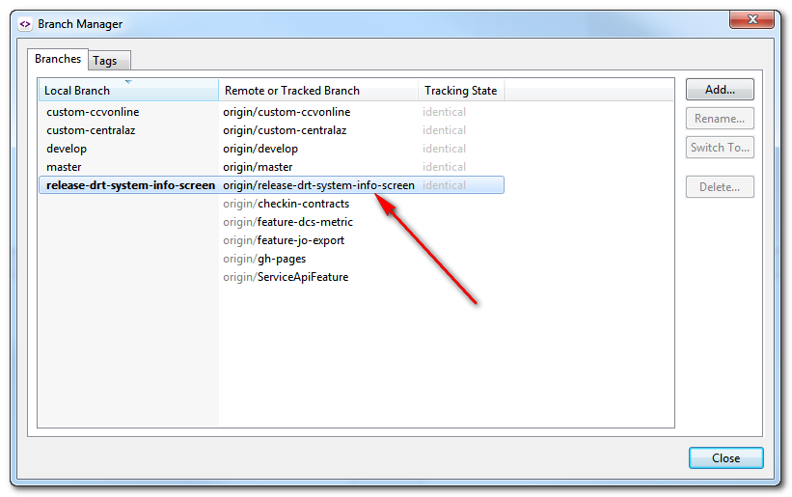

## Switching Branch

Prior to switching branches, you should commit any uncommitted work that has been made for the current branch. Git will attempt to update your working copy with all the committed changes for the branch that you switch to. If you have uncommitted changes, You will likely get an error from Git that will prevent you from switching.

To switch branches, select the *Branch -> Switch* menu option or the Switch button in the toolbar. This will display the branch dialog and you can choose the branch to switch to. Again, Git will update your working copy to reflect the committed state of the branch that you switched to.

## Merging

To merge one branch into another, first switch to the branch that you would like to merge to. For example when merging changes from a feature branch, first make sure all the changes are committed in that branch, then switch to the develop branch.

Select the B*ranch -> Merge* menu option, or the Merge toolbar button. From the Merge dialog window, select the branch/commit that you’d like to merge from…

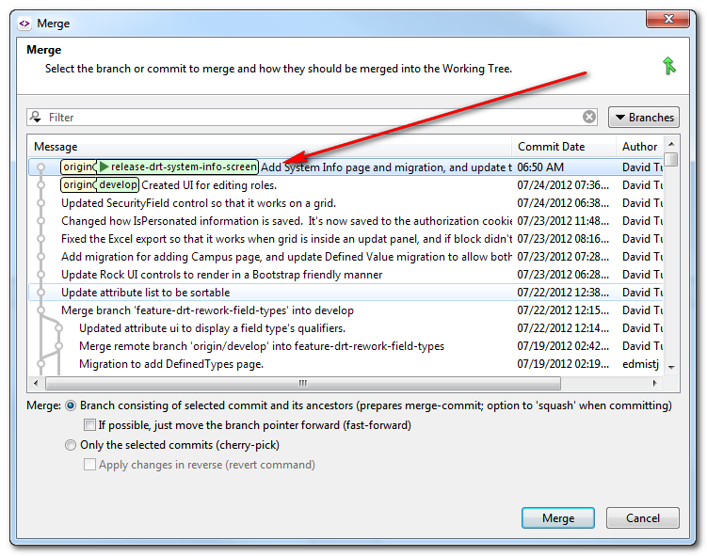

All of the changes from the branch will now be displayed as uncommitted changes to the current branch. There may be some files with conflicts if Git could not figure out how to merge changes from the source branch into the target branch. In this case you will need to look at each conflicted file and choose the appropriate change. Once you’ve saved the change, SmartGit will ask you if the change would be staged (select yes). Once you’ve resolved any conflicts, commit all the changes, and then if necessary do a Pull and Push to update the remote repository.